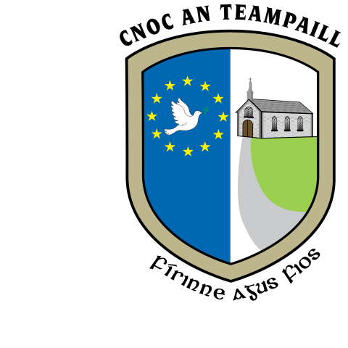
SN Cnoc an Teampaill, Knocktemple NS,
Achadh an Iúir, Virginia,
Co. an Chabháin Co. Cavan
knocktempleschool@gmail.com
049 8547081
Roll No. 17625L

Attendance Strategies

In Knocktemple NS, we value the individuality of all our children and respect their right to access all areas of learning. We work to enable them to develop the knowledge, skills, understanding and attitudes that are necessary for their self-fulfillment and their development into active and responsible adults.

Knocktemple NS decided to review its attendance strategies because:

- It is a requirement under Education Welfare Act 2000
- The school needs to encourage pupils to be in attendance

Aims
In Knocktemple NS we aim:

- To foster an appreciation of learning
- To raise awareness of the importance of school attendance
- To identify pupils at risk of early school leaving
- To enhance the learning environment where children can make progress in all aspects of their development
- To promote positive attitudes to learning
- To ensure that the system of rules, rewards and sanctions are implemented in a fair and consistent manner that encourages pupils to attend school
- To comply with requirements under Education Welfare Act 2000/Guidelines from NEWB.

Strategies to encourage good attendance

- Caring Environment - Knocktemple NS, at all times, aims to ensure that children are taught in a safe secure and caring environment where their intellectual, physical and spiritual development are catered for
- We try to create a welcoming environment for pupils and parents. Teachers consistently try to encourage good attendance in their respective classrooms
- Special Needs – pupils needing support are identified as early as possible and the appropriate support systems put into place. We emphasise positive achievements and do all we can to enhance self-esteem
- Homework Support – The homework club exists to support those pupils whose home circumstances dictate that there is neither the environment conducive to completing homework nor the expertise at home to help with homework. Having completed homework removes a possible excuse for avoiding attending school
- Rewards – Certificates and book tokens are issued for perfect attendance at the end of the school year

Communication

- Parental Support - It is the policy of Knocktemple NS to encourage and maintain open communication between home and school and to encourage parents in their role as primary educators of their children. The Principal and teachers are available, on an appointment basis, to meet parents.
- Attendance is one of the issues addressed at meetings for new parents when their child is enrolled in Knocktemple NS
- It is also covered in the information pack given to all parents of Junior Infant children
- Parents are made aware of the requirements of the Education Welfare Act at pre-enrollment information meetings. Each family is given a copy of the information leaflet - Don’t Let Your Child Miss Out (Leaflet for parents NEWB 2004) This leaflet outlines

- The importance of regular attendance
- Parental obligations in relation to attendance under the Education Welfare Act
- Advice to parents on what they can do to help children attend school regularly.

Parents are reminded regularly of the importance of good attendance (i.e. newsletters, parent/teacher meetings etc.). An awareness of the importance of good attendance by the children, is kept to the forefront in the classroom and at assemblies.

School Records
A roll call is taken every day and should a child be absent, they are required to have an explanatory note from their parents. This may be recorded in the home school diary. The Education and Welfare act ‘obliges the parents of an absent child to notify the school of the cause of absence not later than the third day of absence’. Notes or record of non- attendances are duly dated and need to be kept.

- When a child has missed 20 days, the absence is reported to Tusla as required by the Education Welfare Act. If the absenteeism persists, the school requests active intervention from the EWO.

Ratification
This policy was ratified by the Board of Management of Knocktemple NS on 13th December 2016.

Signed: _______________ Signed: _______________
Chairperson Board of Management Principal
Date:

