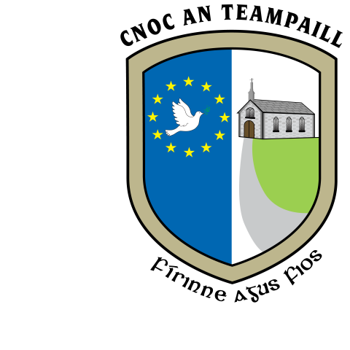SN Cnoc an Teampaill, Knocktemple NS,

Achadh an Iúir, Virginia,

Co. an Chabháin Co. Cavan

A82 PF98 A82 PF98

Roll No. 17625L [knocktempleschool@gmail.com](mailto:knocktempleschool@gmail.com)

049 8547081

**Photography Policy.**

Schools need and welcome positive publicity. Children’s photographs add colour, life and interest to photographs of the school activities and initiatives. Making use of photographs in school publicity materials can increase pupil motivation and staff morale and help parents and the local community identify and celebrate the school’s achievements. However, photographs must be used in a responsible way. Schools need to respect children’s and parents’ right of privacy and be aware of potential child protection issues.

CHILD PROTECTION ISSUES

Risk can occur when individual pupils can be identified in photographs. Providing the name and the photograph of a pupil in a publication or on a website allows for the possibility of people outside the school identifying and then contracting pupils directly. The School has a Child Protection Policy and parents, children and other adults who are aware of any abuse/inappropriate contact with children that may be connected with publicity material should report this immediately to the Principal or Designated Liason Person.

APPROPRIATE USE OF IMAGES

Knocktemple National School adopts the following guidelines when using the photographer of children in school publicity materials, including use of images / names on the school website, newsletters, displays:

1. Teachers will not identify children by name in photographs displayed, in particular when they are provided for publication. The principal will make an informed judgement about what constitutes publication.

2. Only photographs of children appropriately dressed are used. This normally means school uniform. e.g. a pupil winning a competition or a photograph of ‘Junior Infant Class 2019’, may be published in the local / national newspaper. Care is taken when using photographs of children participating in sports activities. We do not use photographs of children participating in swimming events.

3. We never use the image of a child who is known to be the subject of a court order.

4. Providing parental consent is secured, there is no breach of the Data Protection Act in simply passing on a child’s name to a journalist. If the school / parents are concerned that a newspaper has used the photograph and name of a child inappropriately, they should contact the Press Complaints Commission.

5. WEBSITES – When using photographs on websites, the school follows the same rules as other publicity materials. We do not name individual children and identify them in photographs.

6. Pupils must not be approached or photographed while at school without the permission of the school principal.

7. PARENTS FILMING / TAKING PHOTOGRAPHS Parents or other spectators may want to photograph or video at an event such as sports day or the performance of a service or an assembly. This is a valuable part of school life and can be very rewarding for both the family and school. The school reserves the right to ask parents/visitors not to take photographs of children / use videoing equipment if it disrupts an event or the school feels the images may be used inappropriately. Parents are asked to respect the views of others.

8. PARENTAL CONSENT – Knocktemple National School respects the right of parents / guardians to withhold consent from their child’s / children’s photographs being used in school publicity materials. Should parents not want their child’s children’s photographs used in the way described in this policy, they should inform the school. Otherwise it will be understood that the policy has been read and accepted and consent has been given.

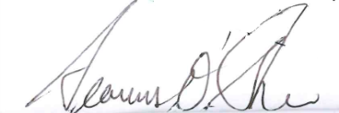This policy was ratified by the Board of Management of Knocktemple N.S. on 12th May 2021. It will be reviewed every three years and amended if necessary.

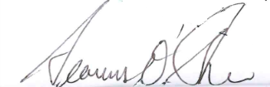

Signed: __________________________ Date: 12th May 2021

Chairperson

