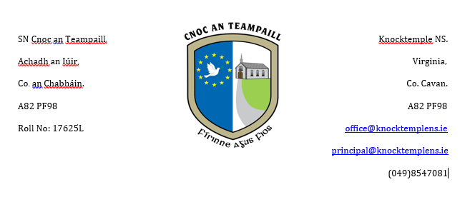

School Calendar 2023-24
Please find below the proposed calendar for the school year 2023-24. If there are any unforeseen changes parents will be informed as soon as possible.
School Reopens: Thursday 31st August 2023 All Pupils
Mid Term Break: Monday 30th October – Friday 3rd November 2023
(School closes Friday 27th October Reopens Monday 6th November)
Christmas Holidays: Monday 25th December 2023 – Friday 5th January 2024
(School closes Friday 22nd December Reopens Monday 8th January)
February Bank Holiday: Monday 5th February 2024
(School closes on Friday 2nd February and reopens on Tuesday 6th February)
Mid Term Break: Thursday 15th February – Friday 16th February 2024
(School closes Wednesday 14th February Reopens Monday 19th February)
St. Patrick’s Day (Bank Holiday) Monday 18th March 2024
(School closes Friday 15th March and Reopens Tuesday 19th March 2024
Easter Holidays Monday 25th March – Friday 5th April 2024
(School closes Friday 22nd March and reopens on Monday 8th April)
May Bank Holiday: Friday 3rd May and Monday 6th May 2024
(School closes on Thursday 2nd May and reopens on Tuesday 7th May)
June Bank Holiday: Monday 3rd June and Tuesday 4th June 2024
(School closes on Friday 31st May and reopens on Wednesday 5th June)
Summer Holidays: Wednesday 26th June 2024

