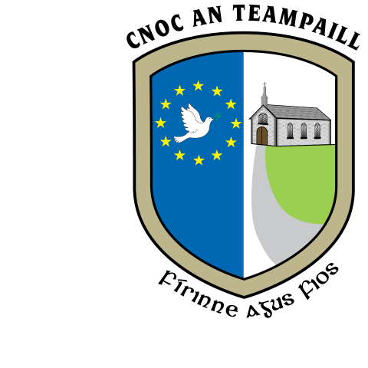

Our Vision
We strive to provide a well-ordered, caring, happy and secure learning environment, where the intellectual, spiritual, physical, moral, aesthetic and cultural needs of our pupils are identified and addressed. We would like to see all our pupils grow up to live full and useful lives as adults in society.

Our Aims

In our school we aim to:
- provide a safe, caring, loving environment that promotes the highest possible achievement for our pupils

- inspire a love of learning among our pupils which is supported by their parents

- model best practice in teaching and learning so that all our pupils are enabled to reach their full potential

- ensure our school is central to the community

- equip our pupils with the self-esteem, confidence, respect, resilience and tolerance to be responsible and contributing members of a global society

- enhance the self-esteem of everyone in the school community, to imbue in the pupils respect for themselves, for other people and for property and to encourage the development of personal responsibility.

MISSION STATEMENT

- Knocktemple NS is a Catholic, co-educational primary school, which strives to provide a well-ordered, caring, happy and safe environment where the intellectual, spiritual, moral, cultural and physical needs of the children are provided for

- While Knocktemple NS is a school with a Catholic ethos, it welcomes and respects children of all religions and none

- Knocktemple NS does not discriminate on the grounds of gender, age, race, disability, marital status, family status, sexual orientation or against members of the Travelling Community when enrolling pupils or appointing staff

- Knocktemple NS encourages the involvement of parents through home / school contacts

- Knocktemple NS will endeavour to enhance the self-esteem of all pupils in the school and promote in them a respect for people and property

- Knocktemple NS strives to promote the professional and personal development of its teachers

- Knocktemple NS promotes gender equality among its teachers and pupils

- Knocktemple NS endorses the principles of inclusion of pupils with Special Needs as set out in the Education of Persons with Disabilities Act, 2003

- Déanfaidh Scoil Náisiúnta Cnoc an Teampaill, iarracht an Ghaeilge a chothú mar theanga bheo na scoile.

