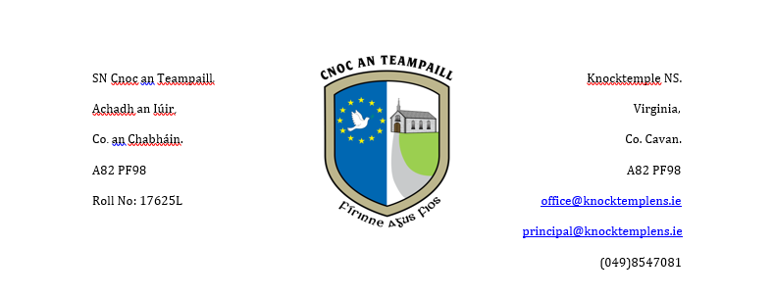

**School Calendar 2025-26**

Please find below the proposed calendar for the school year 2025-26. If there are any unforeseen changes parents will be informed as soon as possible.

**School Reopens**: Thursday 28th August 2025 All Pupils

**Mid Term Break**: Monday 27th October – Friday 31st October 2025

(School closes **Friday 24th October** Reopens **Monday 3rd November**)

**Christmas Holidays**: Monday 22nd December 2025 – Friday 2nd January 2026

(School closes **Friday 19th December** Reopens **Monday 5th January**)

**St Brigid’s Bank Holiday:** Monday 2nd February 2026

(School closes on Friday 30th January and reopens on Tuesday 3rd February)

**Mid Term Break**: Thursday 19th February – Friday 20th February 2026

(School closes **Wednesday 18th February** Reopens **Monday 23rd February**)

**St. Patrick’s Day (Bank Holiday)**  Monday 16th -Tuesday 17th March 2026

(School closes **Friday 13th March** and Reopens **Wednesday 18th March 2026**

**Easter Holidays**  Monday 30th March – Friday 10th April 2026

(School closes **Friday 27th March** and reopens on **Monday 13th April**)

**May Bank Holiday**: Monday 4th May 2026.

**June Bank Holiday**: Monday 1st June 2026

**Summer Holidays**:  **Tuesday 23rd June 2026**