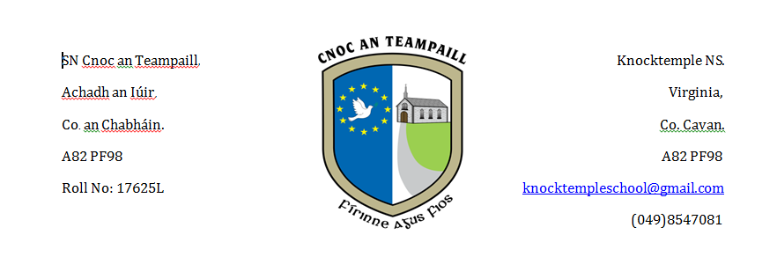

**Relationship and Sexulaity Education (RSE) Policy**

**Knocktemple NS**

**Virginia**

**Co. Cavan**

**Uimhir Rolla: 17625L**

**Our School’s Philosophy/Mission Statement**

Our school is a mainstream, co educational school with ASD classes. strives to provide a well-ordered, caring, happy and safe environment where the intellectual, spiritual, moral, cultural and physical needs of the children are provided for.

Our Mission Statement states that we strive to provide a well-ordered, caring, happy and safe environment where the intellectual, spiritual, moral, cultural and physical needs of our children are provided for. We want our children to be well-balanced, spiritual persons, achieving their full potential with a regard for all human beings. Relationships and Sexuality Education(RSE) as a component of Social, Personal and Health Education (SPHE) furthers this Mission.

**Definition of Social, Personal and Health Education (SPHE)**

SPHE is the process which enables pupils to develop an understanding of themselves. It helps them to choose and follow a healthy lifestyle and enables them to play responsible roles as individuals and as members of society.  
  
**Relationship and Sexuality Education (RSE)  
1. Definition of RSE in relation to SPHE**

RSE is an integral part of SPHE and deals with aspects such as human growth and development, human sexuality, parenting, personal and social skills and relationships. It provides children with opportunities to acquire knowledge and understanding of these areas through processes which will enable them to form values and establish behaviours within a moral, spiritual and social framework.

**2. The Aims of Relationships and Sexuality Education (RSE)**

* To enhance the personal development, self-esteem and well-being of the child.
* To help the child to develop healthy friendships and relationships.
* To foster an understanding of and a healthy attitude to human sexuality and relationships in a moral, spiritual and social framework.
* To enable the child to acquire an understanding of, and respect for, human love, sexual intercourse and reproduction.
* To develop and promote in the child a sense of wonder and awe at the process of birth and new life.
* To enable the child to be comfortable with the sexuality of oneself and others while growing and developing.

**Current provisions for RSE in this school.**

Up to recently Relationships and Sexuality Education has been taught in the context of Religious Education, in Social and Environmental Studies, in Health Education and through positive school climate and atmosphere. We have used lessons and activities from the Religious Education Programme – Alive O, Child Abuse Prevention Stay Safe, Substance Misuse- Walk Tall and Relationships and Sexuality (R.S.E) Programme to do this in conjunction with the religious education programme.

**Management and organisation of RSE in our school.**

**A development approach.**

Teaching about relationships and sexuality will be delivered in the context of SPHE. All content objectives will be taught developmentally by the time the children leave 6thclass. All issues will be discussed with sensitivity, professionalism and awareness of the varying levels of development within a class.

Possible sensitive issues such as naming body parts and sexual intercourse will be covered within the strand units ‘Taking care of My Body’, ‘Growing and Changing’ and ‘Safety and protection’.

**Language**

The acquisition of appropriate language in RSE is crucially important to enable children to communicate confidently about themselves, their sexuality and their relationships. Not being familiar with the biological terms of the body can put the children at a disadvantage.

We will give children the correct and appropriate language as outlined in the RSE material.

* Junior Infants; Womb, Breast Feeding
* Senior Infants; Penis, Vagina/Vulva
* 1st Class; Urine passes through the penis for boys and the urethra in girls. Baby in the womb for 9 months and maybe breast or bottle fed.
* 2ndClass Penis, urethra, vagina/vulva, navel, breast.
* 3rd Class; Stages and sequence of development of the human baby from conception to birth.
* 4th Class; Developing foetus, puberty.
* 5th Class; Puberty, physical changes in boys and girls, reproduction.
* 6th Class; Sexual Intercourse in the context of a loving relationship, such as marriage.

**Organisational Matters:**

* Parents will be informed in advance of lessons on the sensitive areas of the RSE programme
* In May/June of each school year 4th class girls will be taken for a lesson around Menstruation. Parents will be made aware of this via communication from the school
* Parents have a responsibility to become involved, to inform themselves of the programme content and to prepare children for the information they will acquire around the sensitive areas and discuss areas covered in RSE/SPHE. Parents are invited/welcome to view the curriculum and may speak to the class teacher if they have any concerns
* In the class situation children will be encouraged to recognise that certain information is for them only and it would be inappropriate to discuss this with younger siblings/children for example
* With regard to matters of a confidential nature, the school cannot take any responsibility for what is discussed in the yard or classroom. Should a child, who is withdrawn from the sexually sensitive lessons, receive inappropriate information from others outside of these classes, it will be the responsibility of the parents/guardians to address the issues
* If a teacher has concerns about teaching the “sexually sensitive issues” in RSE they should consult with the Principal. Any teacher has the right to opt out of teaching the “sensitive parts” of RSE. It is the responsibility of the B.O.M. to ensure content is covered by another teacher or an outside speaker
* Children with SEN – Taking into account the pupil’s social and emotional development, instruction will be based on individual needs where possible. Parents will be consulted around sensitive issues

In our school, where there is a multi class situation and there are children of different class levels and abilities and where information is inappropriate for the younger age group, we will withdraw them. Our school is a co-educational school and we will teach the boys and girls together.

**Privacy:**Everyone has the right to privacy. Teachers will not answer personal questions about themselves nor require the child to give information of a personal nature which they do not wish to share.

**RSE policy and Other Curricular areas:**  
Our policy on RSE will also inform the teaching of the strand ‘Living Things’ in Science.

**Policies which support SPHE/RSE**

* Code of behaviour and discipline
* Anti-Bullying Policy
* Child Protection Policy
* Enrolment Policy
* Healthy Eating Policy
* Acceptable Use Policy

In keeping with the sentiment and spirit of these policies, we support informally many of the aims on which RSE is modelled. We encourage good behaviour, open communication, understanding and tolerance of differences, and respect for self and others. We recognise that both pupils and staff have rights and responsibilities in our school. A sense of responsibility is fostered and attention is paid to the wellbeing of all of the members of the school community.

**Rights and responsibilities of parents/guardians:**

* In SPHE and RSE parents/guardians are acknowledged as the primary educators of their children and the school will work in a supportive role.
* On enrolment parents will be provided with the schools RSE Policy and the list of possible sensitive issues.
* The parent/guardians will be notified of when the lessons/sensitive issues will be taught prior to their teaching, in order that they will have their children prepared.
* A parents/guardians right to withdraw a pupil from the process will be honoured on the understanding that the parent is taking full responsibility for this aspect of education. It is the responsibility of the parent to inform the school in writing of this decision.
* If parents/guardians choose to withdraw their children from these lessons they can take their children home while the lesson is being taught or have their children accommodated in another classroom.

**Confidentiality:**

If a child is withdrawn for the teaching of sensitive issues we cannot guarantee that the other children will not tell him/her what happened.

**Rights and Responsibilities of Teachers.**

* Each class teacher will teach the SPHE Programme including the sensitive issues.
* A teachers’ right to opt out from teaching the sensitive issues will be honoured. Then provisions will be made for these issues to be taught by a colleague.
* If a member of staff is unavailable to teach the sensitive issues, arrangements regarding the teaching of the programme will be made by the Board of Management.

**Dealing with Questions:**

It is natural that children should wish to ask questions in the area of RSE. However, this area is treated somewhat differently from other subjects due to its sensitive nature.

All questions answered will reflect the parameters of the curriculum. Certain topics are not in the primary RSE/SPHE programme and will not be discussed i.e: abortion, masturbation, homosexuality, contraception.

Questions to the teacher may be oral or written within the group setting and answered within boundaries of the curriculum and school policy. If any questions asked by children are deemed to be inappropriate, the teacher will refer the child to their parents/guardians, or state that this information may be available at a later stage of the curriculum. The school cannot guarantee confidentiality if a child asks a question of a personal nature or discloses personal information.

At all times the child’s and teacher’s right to privacy will be maintained.

Children’s questions will be dealt with, taking into account the following criteria, when relevant

* By being aware of circumstances in which the question has arisen
* By clarifying what information is required
* By deciding if the issue is relevant/who it is relevant to
* By giving an age appropriate answer
* By deferring the question as one which will be answered in the next lesson, one which should be answered at home or one which will be answered more fully in the future.

**Sources and resources:**We will use the RSE and the Stay Safe Programme and the other resources that are deemed suitable by the Principal/SPHE co-ordinator such as a suitable DVD for example Busy Bodies. A booklet which accompanies this DVD is available on www.healthpromotion.ie

* Lesson plans from the DE Resource Material for Relationships and Sexuality Education. Each class teacher has a copy of the appropriate manual
* The Stay Safe programme, the Walk Tall Programme
* Busy Bodies DVD and booklet. This DVD and booklet were developed to support the teaching of the 5th and 6th class components of RSE within the context of SPHE. It is available for download at [www.healthpromotion.ie](http://www.healthpromotion.ie)
* All resources are available for parents/guardians to view if they so request prior to the delivery of the lesson.

**Provisions for on-going support, development and review:**

1. Where necessary or if opportunities arise the Board of Management may be requested to fund/support:  
   - in career development for teachers.  
   - training for parents organised by the National Parents Council.
2. The draft policy was circulated to parents, teachers and the school authorities by February 2005 and amended where feasible. The final agreed policy was presented to the Board Of Management, ratified by them, circulated to all parties involved and implemented.
3. This policy and the RSE programme will be reviewed after two years and every two years thereafter. All partners will be informed of any amendments necessary after such review. RSE resources will also be reviewed to ensure they are kept up to date.

**Date:** 27th March 2014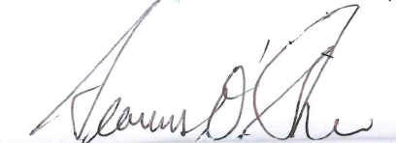

Signed: ____________________________

Chairperson of Board of Management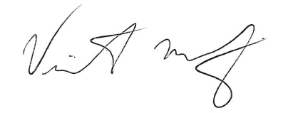

Signed: _____________________________

Principal

Date: 13th December 2016

On the 11th March 2014 this policy was reviewed by the staff. On the 26th March the draft policy was reviewed by the Parent’s Association. This policy is available to parents in the school office.

This policy was further reviewed at a staff meeting on 8th November 2016. The policy was also discussed at an In School Management meeting on 12th December 2016. The policy was then ratified by the Board of Management on 13th December 2016.

The policy was reviewed again during the 2018 – 2019 school year.

The policy was reviewed again during the 2024 - 2025 school year.